Sales Contract Review Workflow

Rares Lutia  
28.07.2011

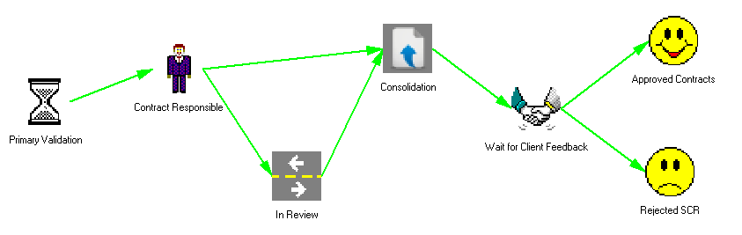

Several pools were defined to cover Sales Contract Review process. These pools are actually document queues. Main queues are :

* Primary Validation – used for marking of income documents with curent user as document responsible
* Contract Responsible – for documents waiting to be indexed by responsible and send them for review to different assigned departments
* In Review – pool of documents waiting to be revied by assigned users/departments
* Consolidation – used at the end of the review process to upload final version of the contract, according to any notes and documents added during the review stage
* Wait for Client Feedback – pool of documents sent to the client for confirmation
* Approved Contracts –the ending stage of the client approved and documents; the final signed version of the contract should be attached
* Rejected Contracts – the ending stage of rejected documents

However, each one is going to be described further in this document.

The Sales Contract Review (SCR) Workflow is asociated to any document indexed as Sales Contract Review document type. This workflow is traking the status of the contracts, making sure that they relate to any existing requirments and processing rules, but also providing a shared environment for comunication during the sales contracts preparation.

## Briefly flow description

The SCR flow was designed to cover the need of collecting informations related to sales contracts, attach suplementary related documents and prepare the final version of the documents.

After a primary document indexing, once the documents are defined as SCR – Sales Contract Review, they are automatically entered into the workflow. They are first placed in the Primary Valdation queue. This is a queue were the system is runing automaticaly tasks. In this moment the curent user that import the document is marked as Responsible of the document (sometimes called owner of the contract in this document).

After Primary Validation the document enters the Finance queue, waiting to be checked by the responsible.

A good practice is ti provide at the importing process only basic and required informations like: Reference Number, Revision Number, Client. The rest of informations may be completed in the first stage available – Contract Responsible.

After importing the document, the document owner assign the users that need to review the contract and send the document further for reviewing. One user per department may be assigned using keywords:

* Finance Responsible
* Quality Responsible
* Planning Responsible
* Engineering Responsible
* Shipping Responsible
* Legal Responsible

After sending the document for Review, it is moved to the next step – In Review queue. Assigned users are notified about the new document that need their attention. Each of the assigned users is able to attach related documents and insert notes. At the end they need to confirm they finished reviewing the document. When all assigned users confirmed they finished reviewing the process, the document is automaticaly moved to the next step – Consolidation.

Here, the document owner is preparing the consolidated version of the contract and attache it as SCR – Sales Contract Proposal document type. This version si also sent to the client for aproving.

When the document was sent, the owner should also mark the contract as sent to client. The document is moved to the Wait for Client Feedback stage.

After the client feedback, the contract should be marked as rejected, if the customer didn’t agree with the proposal and the document is moved to the specific queue.

If the client aproved the constract proposal, it is marked as aproved and the signed version of the contract should be attached as Sales Contract (Signed).

After the aproving process is done, the document eneters the Accounting queue. An accounting responsable makes the final checkings and registeres the invoice; the document is than marked as Processed in SAP – it is moved into this queue to know that the entire checking and aproving cycle was finished for the invoice.

In case of inventory related invoices (raw materials, subcontractor invoices) Finance may send the document to Inventory and Quality for approving.

Also, if needed, the document may be sent to Purchase Manager, and than forwarded to Buyers for informations about the PO or the existing Contract that justifies the prices and discounts used in the invoice.

The following chapters are presenting a more detailed overview of the OnBase Finance document workflow.

## Primary Validation

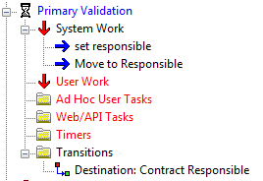Once a document is entered in the system and indexed as ***SCR - Sales Contract Review*** document type, it is placed in the Primary validation pool.

This queue is used for automaticaly tasks to run each time a new contract is imported. Main role of Primary validation queue in this moment is to automaticaly put the name of the user that imported the document as Responsible.

This is configured in the System work branch:

* Set responsible – autocomplete the Responsible keyword with current username
* Move to Responsible – move the document to the next stage – Contract Responsible for further actions before sending for reviewing

## Contract Responsible

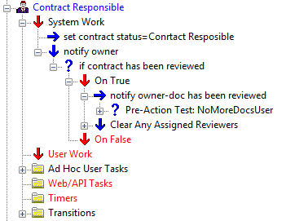Imported contracts are waiting here for completing the indexing process with all the related informations.

Each time a document enters this queue the system work branch is launched:

* Set contract status = Contract Responsible – marks the status of the contract
* Notify owner – this is here only to make sure that reviewed documents are moved to the consolidation queue. It will be described more at the In Review stage

It is important in this queue to assign the users that need to review the document in the fields:

* Finance Responsible
* Quality Responsible
* Legal Responsible
* Engineering Responsible
* Shipping Responsible
* Planning Responsible

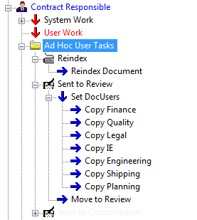It is up to the responsible to decide if all or only some of them should be assigned.

To do this, the owner should use the Reindex Ad Hoc User task (button).

After this, the document responsible must use the Send to Review Ad Hoc User Task to send the document for reviewing. When doing this, the Set DocUsers task list is performed. What actualy this task list is doing is to collect all assigned users into the DocUserID keyword as multiple instances. I.e. , *Copy Finance* is copying the value of *Finance Responsible* keyword into the DocUserID keyword, *Copy Quality* is adding the *Quality Responsible* to DocUserID, and so on.

The DocUserID keyword is used later by the system to check if all users finished the review process, because each time a user is checking the Finish Review button, his/her username is removed from this keyword. Afterall, when DocUserID keyword is having no values, the system knows that all users finished the review process.

NOTE. In this moment there is an Ad Hoc task button that is disabled to allow manual moving of documents into the next queue – Consolidation. However, for some reasons this was decided to be disabled and therefore is not explained here.

## In Review

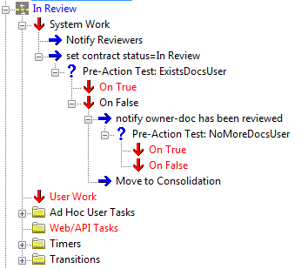When documents get into this queue the following tasks are automaticaly performed by the System Work branch:

* Notify Reviewers – send notification emails to the assigned users
* Set contract status=In Review – sets the Status to PENDING REVIEW. However this is done only if there are users assigned to review the document (DocUserID is having value(s)). Otherwise, the document is forwarded to the Consolidation queue and the owner is notified that the review process is completed.

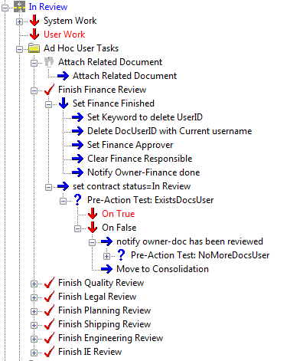Available Ad Hoc User tasks begins with the **Attach Related Document** button. This allowes users to attach related document to the main document. The attached document inherits basic informations from the main document : Reference No, Revision No, Client and any other common keywords. Imported documents are booked as *SCR - Sales Contract Related Documents* document type.

The other Ad Hoc User tasks are provided for each department to confirm finishing of the review process. The reason for different buttons were provided by department is to be able to provide specific email notifications to the document owner when a user confirms finishing the review. Each button is available for specific user groups. At the on of this, as one user is member of a specific department group, he/she will see only nis/her related button.

We’ll discuss the Finish Finance Review only, as the other buttons are doing the same actions but for different departments.

* Set Finance Finished Task list
  + *Set keyword to delete UserID* – put the ID of the field where Finance user is located (i.e. 274 is the ID# of Finance Responsible keyword).
  + *Delete DocUserID with current username* – runs a unity script that remove the user in Finance Responsible (keyword 274 retrived in the previous action) from the DocUserID keyword value(s)
  + *Set Finance Approver* – put the current username as Finance Responsible Approver
  + *Clear Finance Responsible* – remove value of Finance Responsible keyword so the user is no longer assigned to review the document
  + *Notify Owner - Finance done* – send email notification to the Responsible that Finance finished reviewing the document
* 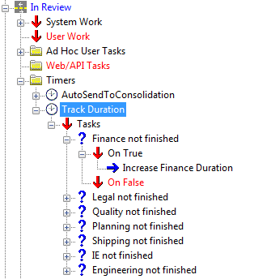Set contract status=in review – this actualy launch the mechanism that checks if any other user is assign to review the document. If no other user is assigned (DocUserID has no more values) an email confirmation is sent to the owner to notify the revieing process was finished and the document is moved to the Consolidation queue.

Timers

The In Review queue is having associated one timer used to count the time a document is waiting to be revied.

Track Duration Timer is checking by department if document is not yet finished, and increase the related keyword value. I. e. , for Finance, the Finance Responsible is checked if has value (user is still assigned) and if it is, Finance Approval Duration keyword value is increased by 1.

While this timer is scheduled to run every working day at 1:00 AM, the Duration keywords will store the number of working days the document wait to be approved.

NOTE. Documents reviewed in the same day will have 0 as Duration.

## Consolidation

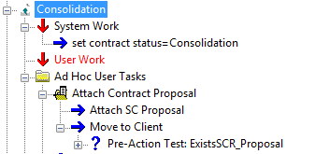This is were somebody puts together the informations collected from the Review stage. In this moment the document owner is supposed to do this task.

The owner is preparing a new version of the contract considering the notes and attached documents coleted in the review process. A new document is created and it must be uploaded in OnBase as SCR – Sales Contract Proposal document type. Same document issent to the client for approving.

Each time a document enters this queue, the status is automaticaly changed to CONSOLIDATION in the System Work branch.

Attach Contract Proposal is the buton provided for the user to attach the consolidated document. If the proposal document was imported, the main document is moved to the next stage – Wait for Client Feedback

## Wait for Client Feedback

This queue is a waiting stage. The responsible is waiting for the customer feedback regarding the proposal sent.

When client responds, the document owner use the two buttons do set the document as Agreed or Rejected by the client.

Documents in this stage are having the status PENDING CLIENT automaticaly completed whe entering the queue.

## Rejected SCR

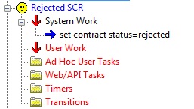When document owner use the Proposal Rejected in the previous queue, the document is moved in this queue.

Nothing more is performed, but the Status is changed to REJECTED.

## Approved SCR

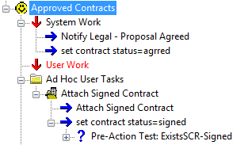When document owner use the Proposal Approved buton in the previous stage, the document is moved here.

Legal department is notified about this and the status of the document is automaticaly changed to CONTRACT AGREED.

When the signed contract is received, it should be imported as attached document . the document owner is using the **Attach Signed Contract** Ad Hoc Usre Task to import the signed document. If the importing process was completed, the document get the Status SIGNED.